1.
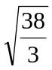

2.
When 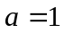, the solution set is 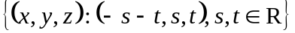.
When 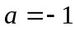, the solution set is 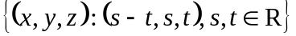.
When 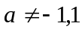, the solution set is 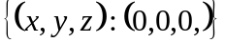.

3.
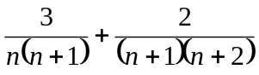 , 4

4.
Prove by mathematical induction.

5.
(i) 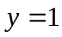 , 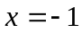 , 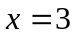
(ii) The function is increasing.

6.
(i)   